PBIO 504 Introductory biostaTISTICs

HW5: Correlation and Linear Regression

Reading Assignment
• Chapters 17 and 18 in the textbook.

The Data Sets

1) Birth weight and gestational age study (note: for some gestational ages there are multiple observations, but all of these data points are independent):

gestage (wks) bwt (grams)
- 1820
- 1900
- 2210
- 2250
- 2500
- 2775
- 2901
- 3090, 3200
- 3270, 3347
- 3400, 3424, 3500
- 3493, 3600, 3616
- 3680, 3720
- 3800

2) Lead and iron exercise (percent of dose absorbed): each value is the amount of the metal (mg) measured in one ml of blood

Study population 1 Study population 2
iron lead iron lead
17 8 11 10
22 17 25 22
35 18 30 33
43 25 44 40
80 58 50 50
85 59 65 52
91 41 71 54
72 30 82 55
96 43 90 57
100 58 100 60
11 3 80 53

INSTRUCTIONS:
1. Make a scatter-plot of the relationship of gestational age (in weeks, on the x-axis) to birth weight (in grams, on the y-axis).
2. Perform a linear regression analysis for the model: bwt = gestage. Add the fitted regression line to the plot. Answer questions 1-6 on the worksheet about the data plot and regression results
3. Make separate scatter-plots of the iron and lead data from the 2 different study populations (it does not matter which variables are plotted on the x- and y-axes). Compute the correlation coefficients and test the null hypothesis that ρ =0 for each population separately. Answer questions 7-10 on the worksheet.
NOTE: do not have to include graphs.

Homework 5 Name: Michael Chambers

Questions about the analysis of birth weight and gestational age:

- What is your impression from the scatter plot with the fitted regression line, in terms of how well the linear regression model appears to fit the data?

My impression of the birth weight and gestational age data scatter plot is that the plotted data follows a positive linear pattern which suggests that there is a positive correlation between gestational age and birth weight, and that there is a linear relationship between the two variables (though this is not a perfect correlation). This does not necessarily imply that gestational age causes birth weight to increase, but the two are correlated (as one rises, so to does the other). Simply looking at the data I suspect that this could be ranked as a high degree of positive correlation between gestational age and birth weight (.75 < r < 1).

- Report the:
- estimated slope: 175.3633)
- estimated intercept: -3431.1795
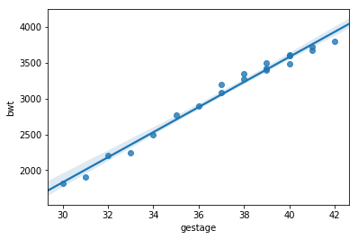
Interpretation: For each 1 week increase in gestational age we would expect the birth weight to increase by ~175 grams. The intercept is -3431 grams (this does NOT mean that a gestational age of 0 has a weight of -3431 grams, that would perilously extrapolate on the provided data).

- Report and interpret the R² value.
R² = 0.9853

Interpretation: There is a strong linear relationship between the variables gestational age and birth weight. Because the r value is positive the linear relationship between these two variables is also positive, as one increases so to does the other. The coefficient of determination indicates that 98% of the variance in the dependent variable (birth weight) is predictable from the independent variable (gestational age). This means that the dependent variable can be predicted from the independent variable with little error.

(4) Report the test statistic and the p-value for the test that the slope equals 0
t = 34.73
DF = 18 (20-2)
p < .00001 (5.9919e-18)

Interpretation: We can reject the null hypothesis (H_{O}: ρ = 0) at an alpha level of 0.05, meaning that there is a significant correlation, or linear relationship, between gestational age and birth weight.

(5) Use the regression equation for a baby born at 38 weeks. What is the predicted birth weight for such an infant?

3232.63 grams

(6) Suppose we want to predict the birth weight of a child born at 28 weeks. How would you do it, or why would you not?

I would NOT predict the birth weight of a child born at 28 weeks because the age range of the dataset upon which this linear regression model is based is 30-42 weeks, and 28 weeks is below and outside that range. To make a birth weight prediction based on the existing data requires that the predicted weight be within the range of existing data. Making a prediction for a 28 week gestation age would perilously extrapolate off the existing data and model.

Correlation results of the analysis of lead and iron data.
(7) Based on the scatter plots of each of the 2 study populations, is it appropriate to perform a correlation analysis? Describe your impressions of the data.
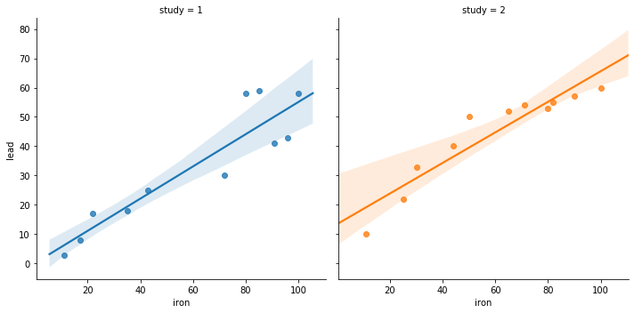

Population 1: Based on the scatter plot of lead and iron blood levels for study 1 I think it would be appropriate to perform a correlation analysis as one variable appears to increase as the other increases in a linear fashion, suggesting that there is a linear relationship between the two variables (thought this is not a perfect correlation). I will note that there appears to be more variance in the lead values as iron values increase.

Population 2: Based on the scatter plot of lead and iron blood levels for study 2 I think a correlation analysis may not be as appropriate to apply in this case. I think there is a positive relationship between the two variables (as one increases, so to does the other), but this does not appear to be a clear linear relationship. Rather, I think there may be an exponential relationship between iron and lead in study two such that lead levels begin to plateau as iron levels increase. This relationship may become more apparent with more data covering a wider range. It may be sufficient to incorporate a linear model for this study dataset, but I suspect that the coefficient of determination for study 2 will be lower than the coefficient of determination for study 1.

(8) Report the correlation coefficients:
r in population 1: 0.91696
r in population 2: 0.935395

(9) Report the test statistic and the p-value from the test that ρ =0 in population 1; interpret the results:

T-statistic for study 1: 9.751
DF: 9 (11-2)
p-value = 2.36e-5

Interpretation: We can reject the null hypothesis (HO: ρ = 0) at an alpha level of 0.05, meaning that there is a significant correlation, or linear relationship, between iron and lead blood levels in study 1.

(10) “Outliers” are said to be a potential problem for correlation and regression analyses – why do you think this is so? How would an outlier data point affect the results of a correlation analysis and how might it affect the results of a linear regression?

By definition, outliers are atypical values or observations that are also infrequent. They can heavily sway the correlation value in misleading ways (false positive), artificially increasing the correlation coefficient or even degreasing the value (false negative). The t-statistic is highly sensitive to extreme values and can yield misleading results because outliers are extreme values that greatly affect the slope of the regression line. Regarding the affect of outliers on linear regression, in the least squares method such extreme values would heavily impact the slope of the line because they would be a greater distance from the line than the rest of the data points and that distance would be squared, further exacerbating the impact that point has on the slop of the regression line.

